Project Design / Planning Phase
Data Flow Diagram & User Stories
Date | 15 October 2026
Team ID | SWTID-2026-6181
Project Name | AI FITTRACK API
Maximum Marks

The supplied template defines a DFD as a visual representation showing how data enters/leaves the system, how information changes, and where data is stored.
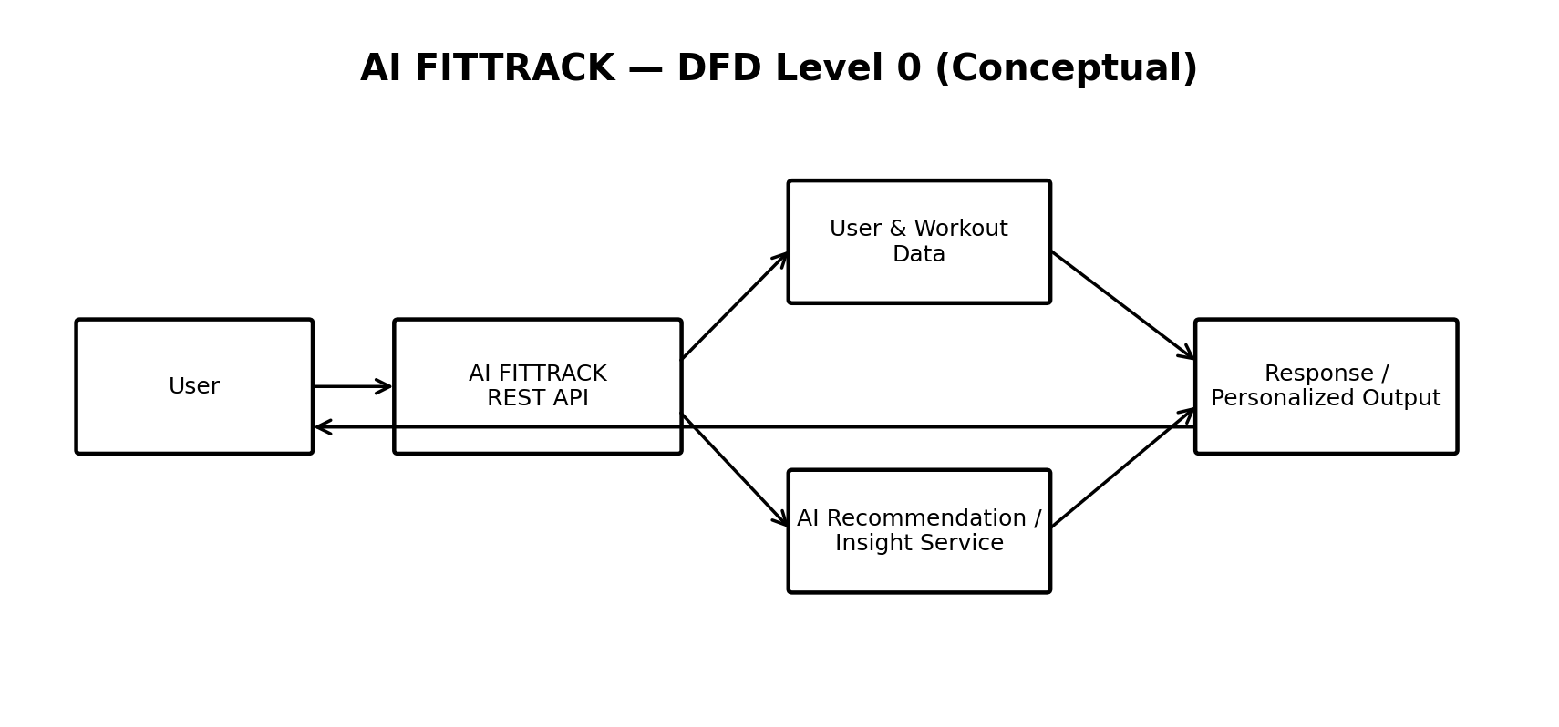
Figure 1: Conceptual DFD Level 0 for AI FITTRACK.

User Stories
User Type | Functional Requirement (Epic) | User Story Number | User Story / Task | Acceptance Criteria | Priority | Release
Fitness User | Authentication | USN-1 | As a user, I can register for AI FITTRACK. | I can create an account and access protected features. | High | Sprint-1
Fitness User | Authentication | USN-2 | As a user, I can log in securely. | I receive a valid authentication token and can access protected endpoints. | High | Sprint-1
Fitness User | Workout Management | USN-3 | As a user, I can add a workout record. | The workout is stored and associated with my account. | High | Sprint-1
Fitness User | Workout Management | USN-4 | As a user, I can update or delete my workout records. | The selected record is updated or removed. | High | Sprint-2
Fitness User | Workout Search | USN-5 | As a user, I can search my workout records. | Relevant workout records are returned. | Medium | Sprint-2
Fitness User | AI Recommendation | USN-6 | As a user, I can receive personalized AI workout recommendations. | The API returns a recommendation based on workout context. | High | Sprint-2
Fitness User | AI Insights | USN-7 | As a user, I can receive AI-powered fitness insights. | The API returns an AI-generated insight based on available workout information. | High | Sprint-3

